# Based on your group preferences, the best restaurant is:

Da Gennaro

* Contact number: +12124313934
* Address: ['129 Mulberry St', 'New York, NY 10013']
* Consumers' favorite: [('Rigatoni Alla Vodka', '$19.00'), ('Margherita Pizza', '$18.00'), ('Fettuccine Alfredo with Chicken Lunch', '$14.95')]

## Consumers Who Have Been There Said:

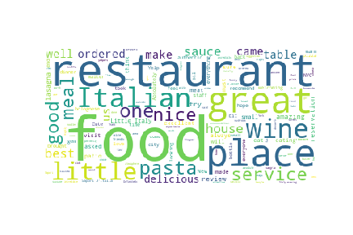

## In compare to other restaurants in destination:

first item in unordered list

## Other considerations for your group:

* Paesano of Mulberry Street
* Gelso & Grand